# freETarget

Application Note: Going Wireless

**SUMMARY**

This application note details the components and configuration needed to implement a wireless connection.

**REQUIRED**

|  |  |  |
| --- | --- | --- |
| Item | Description | Obtained From |
| 1 | freETarget V2.2 or higher |  |
| 2 | freETarget firmware V3.2 or higher |  |
| 3 | ESP-01 | Amazon <https://www.amazon.com/Wireless-Transceiver-Receiver-DC3-0-3-6V-Compatible/dp/B07R4MXPLF/ref=sr_1_12?crid=3V1D0J59OCRTH&dchild=1&keywords=esp-01&qid=1624114287&sprefix=esp-01%2Caps%2C169&sr=8-12>  Or Similar |
| 4 | ESP-01 5Volt Adapter | Amazon <https://www.amazon.com/Aideepen-ESP8266-Wireless-Adapter-Compatible/dp/B01M09B43H/ref=sr_1_3?dchild=1&keywords=esp-01+5V&qid=1624114362&sr=8-3>  Or Similar |
| 5 | 6 Pin IDC Connector | Digikey https://www.digikey.com/en/products/detail/te-connectivity-amp-connectors/3-640441-6/698225  Or Similar |
| 6 | 24 Guage Hookup Wire |  |

**INTRODUCTION**

freETarget supports a WiFi connection using the accessory connector and an off-the-shelf ESP-01 Serial WiFi transceiver. Using the ESP-01, freETarget appears as a WiFi hotspot that when a connection is made transmits the score JSON message to the PC program.

Installing the ESP-01 consists of the following steps

* Build the ESP-01 interface
* Attach the ESP-01 to freETarget
* Select the target name
* Power Up
* On the PC choose the freETarget SSID for your target
* On the freETarget PC application, choose WiFi and CONNECT

**ASSEMBLING THE WiFi INTERFACE**

**Building the ESP-01 Adapter**

The ESP-01 is a self-contained circuit that operates at 3.3 Volts. freETarget operates at 5.0 Volts, so connecting an ESP-01 directly to the board will damage the ESP-01 circuit. Fortunately, adapter circuits are available that convert the voltage levels. Install the ESP-01 into the adapter as shown in Figure 1.

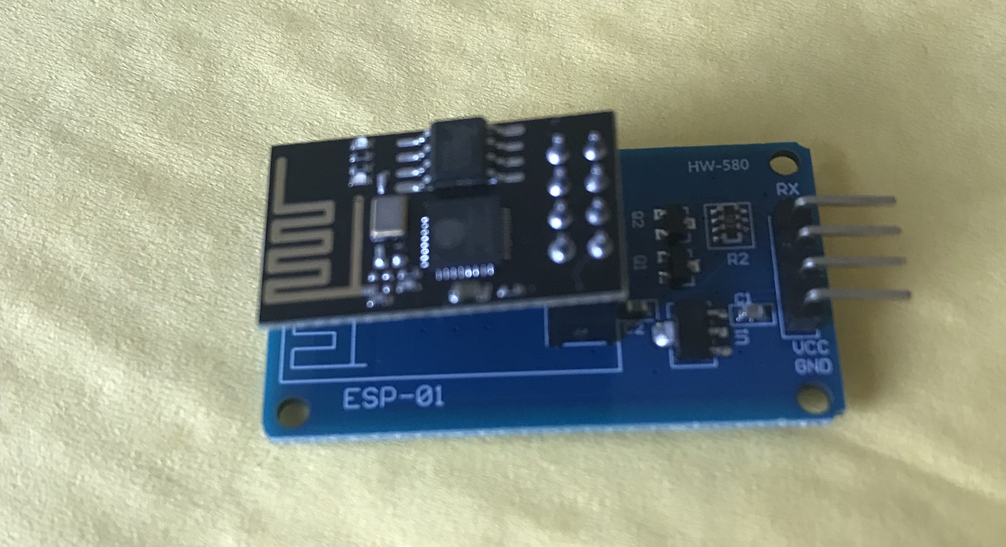

Figure 1: ESP-01 and Adapter Assembly

The ESP-01 and freETarget connect to each other using a short six pin connector illustrated in Figure 2. While the ESP-01 adapter uses four pins and freETarget uses six, for the purposes of convenience two six pin connectors can be used.

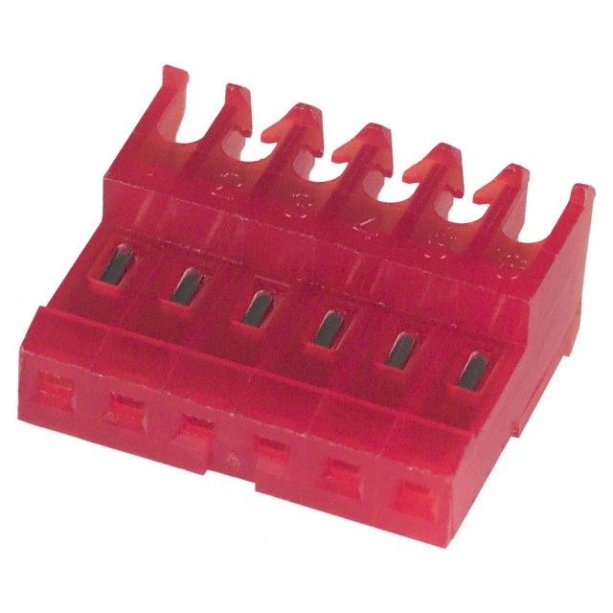

Figure 2: Sample IDC Connector

The wiring for each of the connectors is found in Table 1.

Table 1: WiFI Cable Harness

|  |  |  |
| --- | --- | --- |
| freETarget  Connector | Description | ESP-01  Connector |
| 1 | 5VDC | 2 |
| 2 | Auxiliary Transmit Data | 4 |
| 3 | Auxiliary Receive Data | 3 |
| 4 | Motor Drive (Not Used) |  |
| 5 | Spare (Not Used) |  |
| 6 | Ground | 1 |

**Connect the ESP-01 to freETarget using the cable harness.**

IMPORTANT

When connecting the cable harness to the ESP-01, ensure that Pin 1 of the connector mates to Pin 1 of the adapter. Pins 5 and 6 will overhang the board and not be connected.

**Naming the Target**

freETarget allows you to assign a name to each target for identification. This name appears in the SSID of the WiFi sources on your computer. If you are using a single lane freETarget, the default name “FET-TARGET” can be used for the SSID.

In larger installations a name can be chosen from Table. Use NAME setting found in the PC program setup tab.

Table 2: freETarget Lane Names

|  |  |
| --- | --- |
| Name ID |  |
| 0 | TARGET |
| 1-10 | Numeric 1-10 |
| 11-18 | Seven Dwarfs  “DOC", "DOPEY", "HAPPY", "GRUMPY", "BASHFUL", "SNEEZEY", "SLEEPY" |
| 19-27 | Eight Reindeer  "RUDOLF", "DONNER", "BLITXEM", "DASHER", "PRANCER", "VIXEN", "COMET", "CUPID", "DUNDER" |
| 28-32 | Norse Gods  "ODIN", "WODEN", "THOR", "BALDAR" |

PC Interface

John

Please put in screen shots of the appropriate parts.

**SPECIFICATIONS**

When an ESP-01 is attached to freETarget, the firmware will detect the ESP-01 and automatically configure the connection.

**SSID**

The WiFi SSID connection will take on the name of the target, FET-<name>. For example FET-TARGET or FET-RUDOLF.

**freETarget IP Address**

The freETarget IP address is fixed and is 192.168.10.9

**PC IP Address**

The ESP-01 contains a DHCP server and will assign the PC an address of 192.168.10.0

**Server Connection**

The PC acts as a client to freETarget, and connects to freETarget on port 1090